Cardiac Physiome Meeting Abstract Guidelines
Physiome Organizing Committee, Edwards Lifesciences Foundation Cardiovascular Innovation and Research Center and Department of Biomedical Engineering, University of California, Irvine

File
A single PDF file should be uploaded with the filename “LASTNAME_Physiome2023,” with the presenting author’s last name.

Format
Abstracts should be no more than one page typed, single spaced. The abstract should be formatted with 0.75-inch margins on the top, left, right, and bottom, in 11pt Times New Roman font, and contain no more than two figures. Section headers should be bolded and start a new line. The abstract title should be bold, underlined, and followed by all authors and affiliations. The presenting author should be denoted with an asterisk (e.g., Alisha Smith*).

Composition
Abstracts should include the following sections:
- Introduction: Include background information for the study, including prior literature, its limitations, and why the present work addresses critical knowledge gaps in the field.
- Materials & Methods: A brief overview of experimental and/or computational methods used in the study. This should include (when appropriate) the number and type of experimental samples used, what experimental or statistical methods were applied, what language computational simulations were used with, and relevant model analyses (e.g., sensitivity analysis). Authors should motivate why methods are being used and should parallel the rationale provided in the introduction.
- Results & Discussion: A summary of the findings of the study, computational and/or experimental, and discussion related to the novelty of the findings. Authors should be sure to link the limitations in the literature to their new findings. A single figure with a figure caption can be provided (see below for an example).
- Conclusion: A concise summary of the implications of the study, its significance, and (if appropriate) limitations and future directions.
- Acknowledgements (optional): If space is available, please acknowledge funding sources and other contributors to the project.
- References: Literature referred to in the abstract, including the first author’s last name and first initials, abbreviated journal title, year of the publication, volume number, and page numbers. (e.g., [1] Crampin, EJ, et al. Exp Phys 89:1-26 (2004). [2] Eisenberg, MC, et al. J Theor Biol 324:84-102 (2013).)

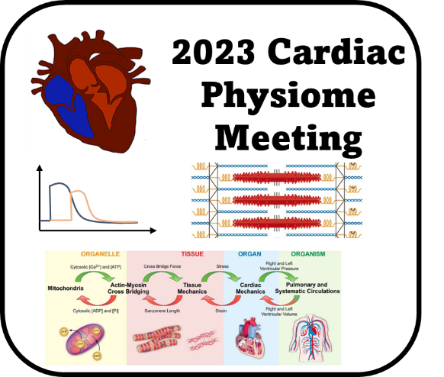
Fig 1: Cardiac Physiome 2023 advertising logo. Note inset heart schematic, activation time courses, sarcomere graphic and image representing multiscale approaches to cardiovascular modeling.

